Media Release
The Third Beneficiary Selection Committee held in the Municipality of Velika Plana reached the Final Beneficiary List for the donation of construction material, basic furniture and home appliances and performance of priority construction works.
Within the European Union program supporting recovery of floods affected areas in Serbia, Danish Refugee Council (DRC) facilitates the reconstruction of 170 individual housing objects affected by recent floods, the installation of 14 prefabricated units, the provision of 184 basic household appliances and furniture sets for the most vulnerable households, as well as the reconsolidation of 54 business activities of small and micro enterprises (with the co-applicant Eneca) in seven targeted municipalities.
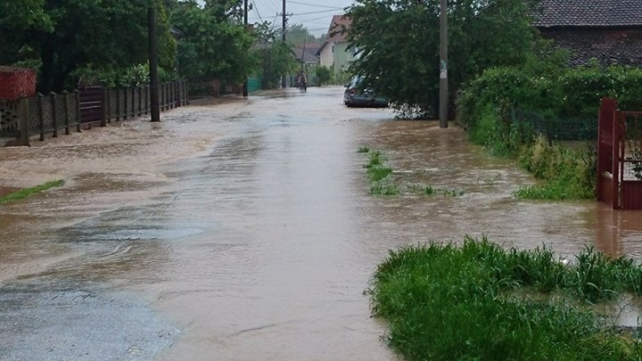
On 3 September 2014, the Second Selection Committee was held in the Municipality of Velika Plana providing the Proposed Beneficiary List of 12 potential beneficiary households selected for the donation of construction material and basic set of furniture and home appliances and performance of priority works on the housing objects affected by floods in May. Eight days after, with no complaints registered, the Final List of 12 Beneficiaries was confirmed and publicized on the Information Boards of the Municipality of Velika Plana.
Final Beneficiaries were selected based on Pre-selected List of 36 beneficiary households and in the line with the adopted Implementation Methodology with the emphasis on vulnerability factor of the family household and field verification process of affected housing house for which the supporting documentation was also obtained.
According to the preliminary schedule, construction works in Velika Plana are expected to start during the first half of October, when the Letters of Donation with selected beneficiaries will be signed and the most quality work contractors delivered the material for rehabilitation.
EU relief program for assistance to the flooded areas in Serbia in the amount of EUR 30 millions is funded by European Union from its IPA funds. The funds are allocated for the construction of new homes, the reconstruction of public institutions, private homes and roads and the revival of economy and agriculture in 24 municipalities seriously affected by the floods: Bajina Basta, Valjevo, Varvarin, Velika Plana, Jagodina, Kosjeric, Koceljeva, Kragujevac, Kraljevo, Krupanj, Lazarevac, Loznica, Ljubovija, Mali Zvornik, Obrenovac, Osecina, Paracin, Svilajnac, Smederevska Palanka, Trstenik, Ub, Cacak, Sabac i Sid. All field activities are implemented by United Nations Office for Project Services (UNOPS), Food and Agriculture Organization of the United Nations (FAO), the organisations HELP, ASB and Danish Refugee Council (DRC) in coordination with the Government Office of the Republic of Serbia for Reconstruction and Flood Relief.
The Danish Refugee Council is solely responsible for the content of this media release, which does not necessarily represent the views of the European Union.
For further information on the project, please kindly address to:
Verica Recevic
Program Manager
Danish Refugee Council - DRC
Mob: +381 (0) 65 591 96 80
E-mail: verica@drc.org.rs

For further information on overall Program, please kindly address to:
Petar Janjatovic
Communications Manager
United Nation Office for Project Services - UNOPS
Mob: +381 (0) 63 862 2780
E-mail: petarj@unops.org

