15.9.2014

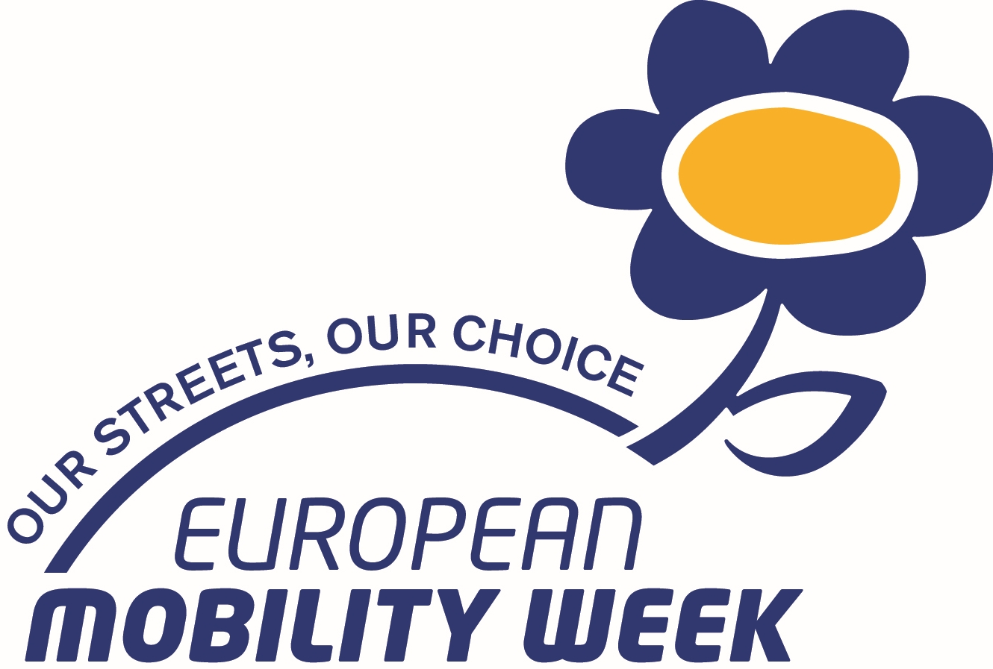
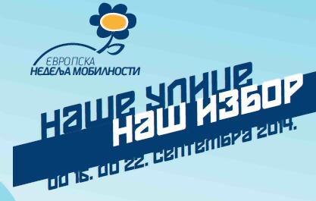

SAOPŠTENJE ZA ŠTAMPU

SRBIJA se četrnaesti put uključuje u akciju Evropska nedelja mobilnosti. Do sada je više od 70 naših gradova uzelo učešće u ovoj akciji kojom se ukazuje na potrebu smanjenog korišćenja automobila u gradovima i promovisanje ekološki opravdanih vidova prevoza, JGS-a, bicikla i pešačenja.

Sledeći gradovi u Srbiji su prema propozicijama EK potpisali povelju i obavezali se da u nedelji od 16 – 19. septembara organizuju određene aktivnosti: Subotica, Kikinda, Senta, Niš, Kragujevac, Šabac, Srbobran i Novi Sad. Time su se pridružili grupi o 1672 grada iz Evrope.

Ovogodišnja akcija ima za moto „Naše ulice – naš izbor“ i usmerena je ka ackijama koje imaju za cilj proširenje slobodnih površina za pešake i bicikliste i transformaciju gradskih prostora u humanije.

JCK je kao i svake godine pripremila paket zvaničnih materijala za promociju ENM koji sadrži prevod i dizajn zvaničnog flajera i CD sa uputstivma o organizaciji ENM, tehnička uputstva, prpagandni film i publikaciju o značaju bicikla. Zainteresovani mogu dobiti materijal

U nastavku je prikaz zvaničnog saopštenja za štampu evropskog koordinacionog tima.

Nacionalni koordinator za ENM za Srbiju

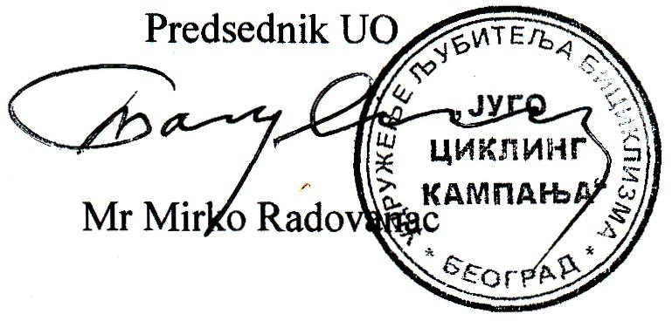

Press release

Hundreds of European towns and cities are expected to participate in the 13th edition of European Mobility Week, an annual campaign promoting sustainable urban travel. This year’s edition will run from 16 to 22 September under the slogan ‘Our streets, our choice’. It raises awareness of the impact of transport on city planning, and encourages citizens to ‘reclaim’ urban spaces in order to create the city they want to live in.
The 2014 edition of European Mobility Week is putting the citizen at the heart of the campaign. Private vehicles have historically determined how cities are planned, often at the expense of other forms of transport. This has made cities more congested, polluted and noisy compromising people’s quality of life. Evidence shows that the current dominance of cars affects people’s health as well as the environment and biodiversity. €100 billion annually is lost due to congestion located in and around the EU’s cities, affecting purchasing power and making citizens poorer.

Therefore, citizens are being called to give their view on how to shape where they live - their streets. Throughout the week, they have the chance to experiment with how their city is planned. With citizen movements sprouting all over Europe reclaiming streets, local authorities therefore have the responsibility to develop urban transport strategies that put the citizen first, protect the environment and make the city a better place to live.
By adopting the slogan “Our streets, our choice” – European Mobility Week is underlining that we all have a part to play, and that even small changes, such as pedestrianizing streets or building new cycle lanes rather than supporting car use, can significantly enhance the quality of life in European town and cities.
European local authorities are invited to sign up to the European Mobility Week Charter and publish their programmes on www.mobilityweek.eu. Towns and cities planning a full week of events from 16-22 September, introducing permanent measures and setting up a car-free day can also apply for the European Mobility Week Award and join the prestigious ranks of previous award winners Ljubljana (Slovenia), Zagreb (Croatia), Bologna (Italy) and, Gävle (Sweden).

- What is happening in 2014?
More than 2,000 cities in 43 countries are expected to officially take part in the 2014 edition of European Mobility Week. National and local campaigners will organise a wide range of activities for different target groups, including sustainable commuting challenges, teleworking campaigns, air quality measurements, flash mobs, car free day events, creative competitions, conferences, public debates, cycling and walking tours, festivals etc.
This makes it almost impossible to provide a complete overview of activities and measures taking place at local, regional and national level. For more specific information on local campaign programmes, we advise you to take a look at http://www.mobilityweek.eu/cities?year=2014
The initiatives below offer a taster of this year’s events.
EMW INITIATIVES AT LOCAL LEVEL
Aarhus, Denmark – Rolling Mobility Lab
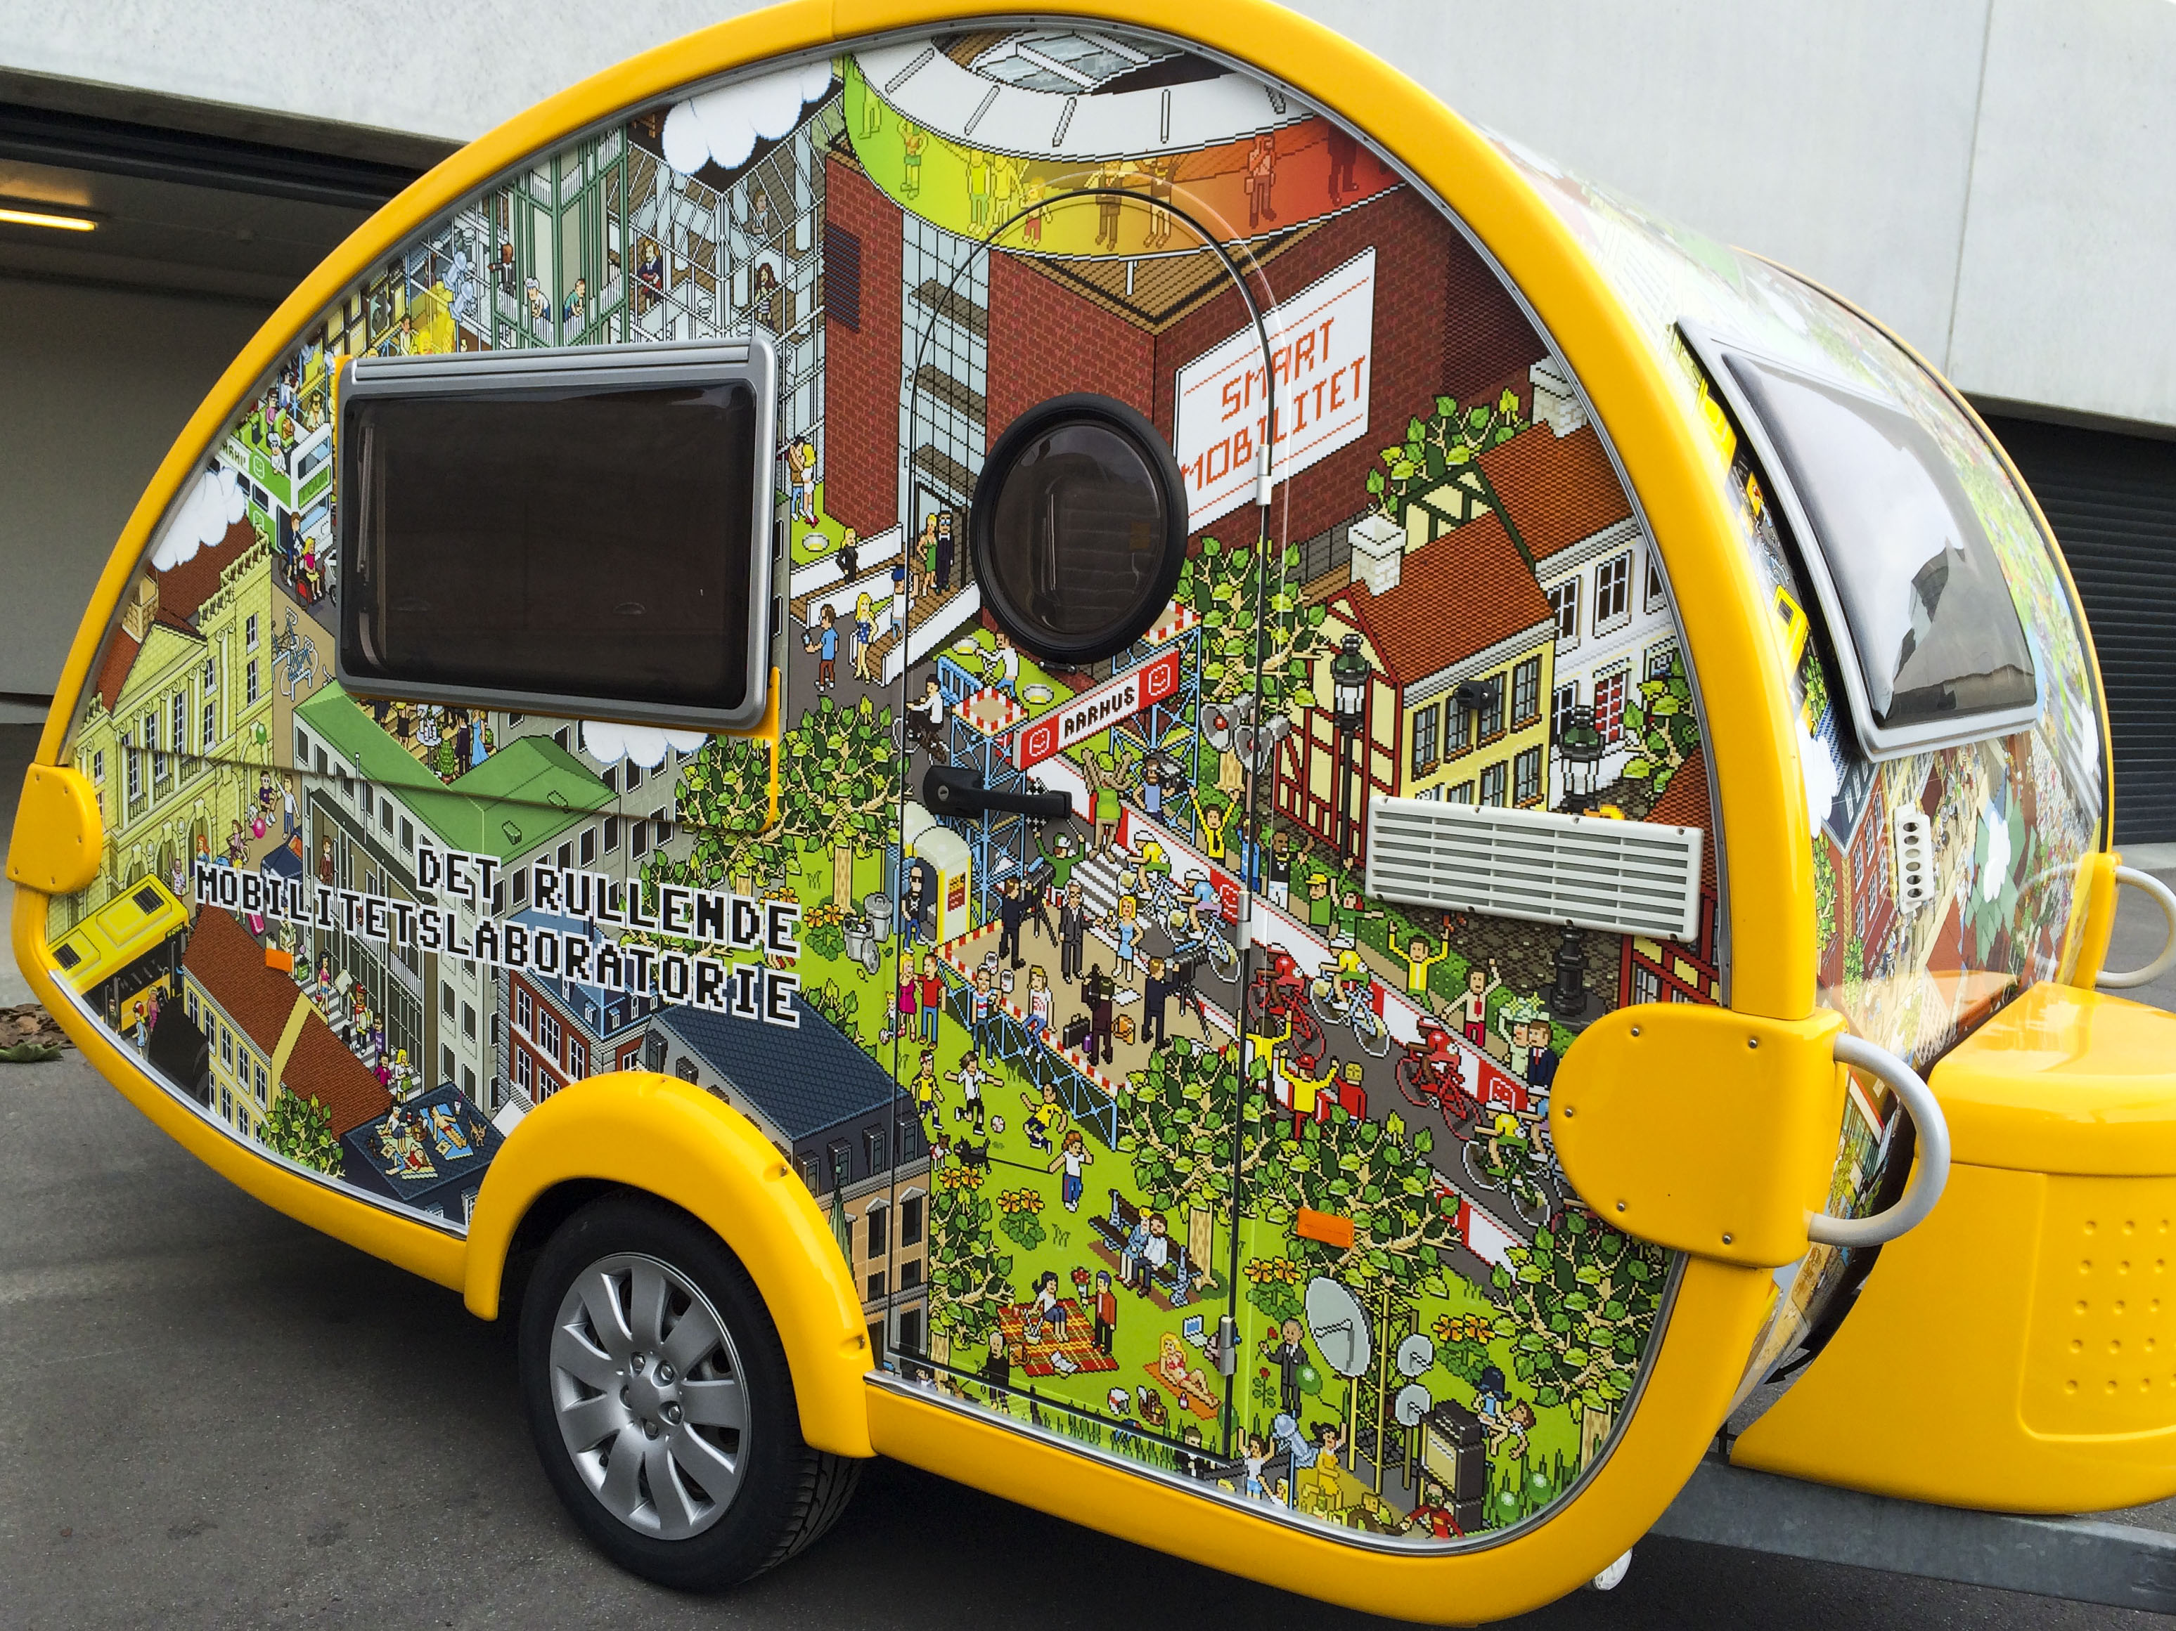
One of the highlights during this year’s EMW in Aarhus will be a small caravan called the Rolling Mobility Lab as part of the smart mobility project. It will be a tool to reach out to citizens in order to create new mobility measures. Citizens will have the chance to co-create new measures so that they benefit them directly making them attractive enough for them to change their travel behaviour with the added benefit of reducing congestion in the city.
Image: City of Aarhus
Ghent, Belgium – Living Streets 2.0
Kicked off in 2013 by volunteers from Ghent’s Climate Alliance in order to experiment on how the city’s mobility landscape will look in the future it re-assed the way public space is managed and social interaction between residents develops. In 2014, volunteers from the Trojan Bike network and inhabitants of the city of Ghent will turn 10 regular streets into car-free “living streets” during the month of June. These living streets will be open spaces for people to socialise, eat outside, study and play. The aim is to have residents take advantage of other modes of transport, as cars normally parked on the streets will be moved to nearby car parks.
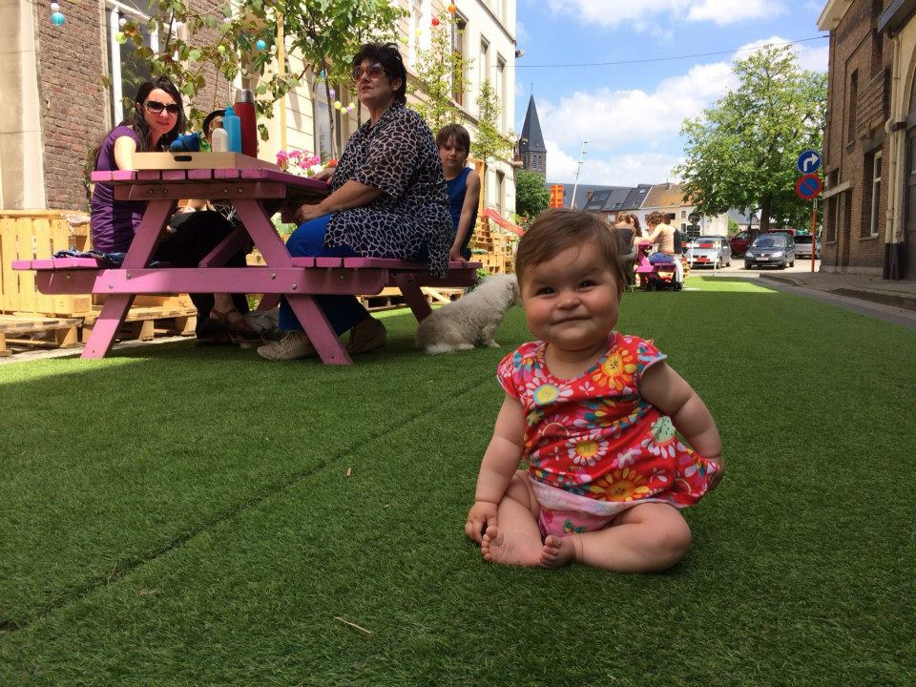

Image: Fiets van Troje
Valencia, Spain – Compas Centre
When the Valencia city walls were demolished in 1865, the area gave way to a shared space for bicycles, public transport and pedestrians moving between the city centre and outlaying districts. Recently however, the area was transformed into a ring road for motor vehicles. The aim of this action is to revert this inner ring road back to a car-free public space for sustainable mobility, first for a single day, and eventually permanently.
EMW INITIATIVES AT NATIONAL LEVEL

Austria – ‘Blooming streets’ painting competition
During EMW, municipalities across Austria will give children the opportunity to reclaim the streets by allowing them to paint them the way they would like to shape them. This initiative is organised through schools and with the best effort given a prize at the end.
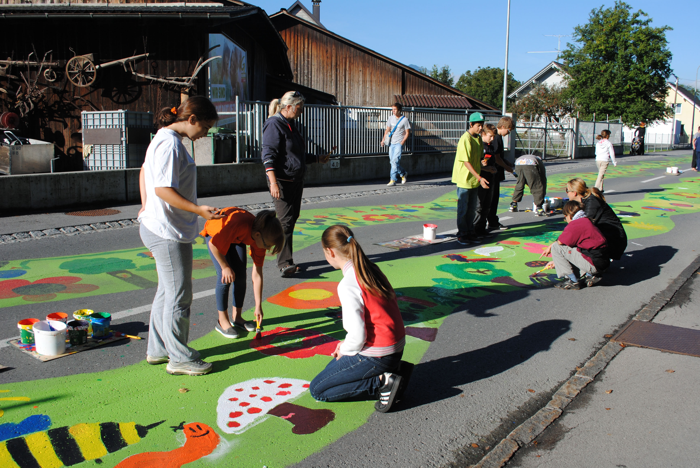

Image: Climate Alliance Austria

Portugal
The Portuguese ‘Agency for Sustainability and Competitiveness’ will support an intermunicipal network of 11 local authorities – including Águeda, Albergaria-a-Velha, Anadia, Aveiro, Estarreja, Ílhavo, Murtosa, Oliveira do Bairro, Ovar, Sever do Vouga and Vagos - with the organisation of activities promoting liveable streets. The campaign programme includes a wide range of events, such as the introduction of 30 km/h zones, the organisation of cycling and walking tours, a transport and mobility seminar, events in schools, painting of pedestrian crossings, renewal of sidewalks, parades of alternative vehicles and even a full day of activities dedicated to people with reduced mobility and special needs. On the occasion of European Mobility Week, local residents will also be invited to contribute to the Transport and Mobility Plan for the Region of Aveiro as well as to the Sustainable Mobility Strategy of Águeda.

Luxembourg – ‘Mr and Mrs Mix a lot’
The Greater Region of Luxembourg is looking for its Mr and Mrs Mixalot! The citizen who mixes their transport modes best? Public transport users are asked to pose with symbols representing the different modes of transport they mix to get to work or to school. A professional photographer takes their picture, which then is posted on the city’s public transport Facebook page. The users share their pictures and invite friends to vote for them. The winners receive free public transport tickets and a specially designed board game, centred on the use of multiple modes of transport
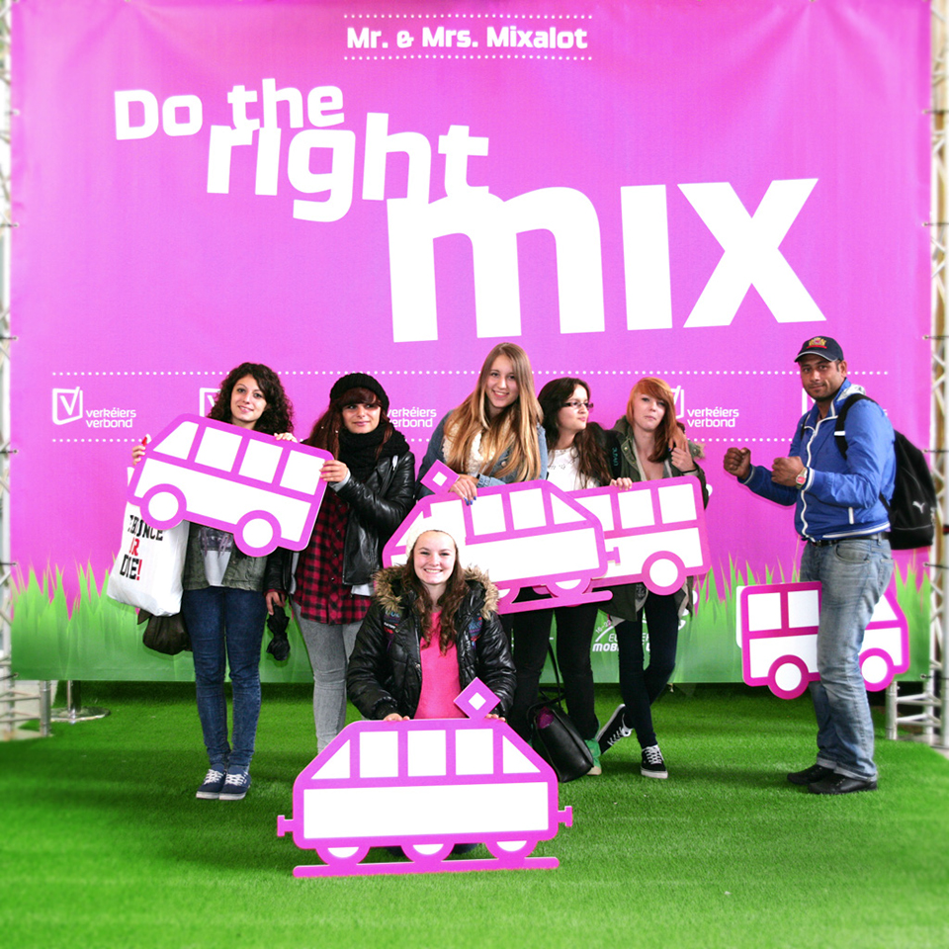
Image: Verkeiersverbund

- Background information:

ABOUT THE CAMPAIGN
European Mobility Week is an annual campaign on sustainable urban mobility, organised with the support of the European Commission Directorate-General for Mobility and Transport. The aim of the campaign, which runs from 16-22 September every year, is to encourage European local authorities to introduce and promote sustainable transport measures, and to invite citizens to try out alternatives to the private car.
The European Mobility Week journey started in 1998 with the French ‘In Town Without My Car!’ day. This initiative still runs today on 22 September of each year to encourage towns and cities to close one or several streets to motorised vehicles for an entire day. This allows citizens to see a different side to their towns and cities, and means local authorities can put into place actions aimed at restricting motorised traffic in certain areas, encourage the use of sustainable modes of transport and raise awareness of the environmental impacts of citizens’ modal choice. The success of ‘In Town Without My Car!’ day and the positive reaction of citizens led former European Commissioner for the Environment, Margot Wallström, to launch a more ambitious initiative in 2002: European Mobility Week.
Since then, the impact of European Mobility Week has steadily grown, both across Europe and around the world. In 2013, 1.931 cities, representing 176 million citizens, officially registered for the campaign. A total of 8.623 permanent measures have been implemented, mainly focusing on infrastructure for cycling and walking, traffic calming, improving transport accessibility and raising awareness about sustainable travel behaviour. To put these numbers into perspective, consider the impact EMW has had through the examples in the next section.
More information:
- General information and news updates
- Participating cities

ABOUT THIS YEAR’S THEME AND SLOGAN

Our streets, our choice
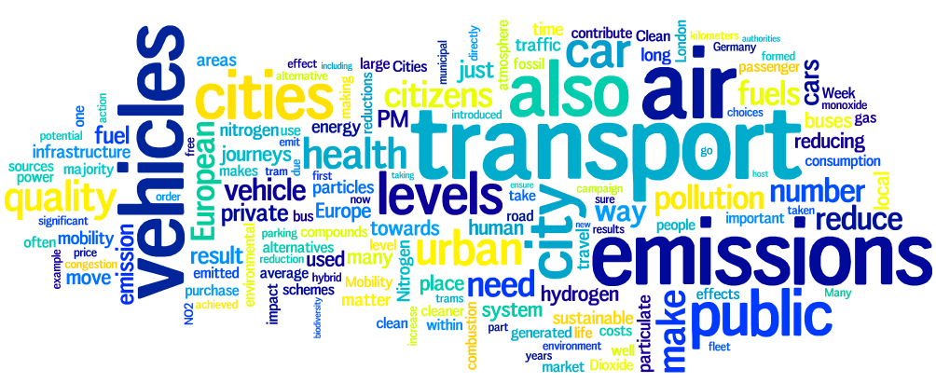
How can people improve urban quality of life? European Mobility Week 2014 aims to re-evaluate the way we think about urban space and to explore the relationship between land-use and quality life. The slogan for European Mobility Week 2014 is ‘Our streets, our choice’ which encourages people to create the city that they want to live in.

The facts are clear – cities tailored to citizens' needs are safer, healthier and less polluted. From the mid-twentieth century onwards, cities were designed with provision for private vehicles as a priority, overshadowing other forms of mobility. This has contributed to urban sprawl, with the development of low-density, car-dependent communities and areas on the outskirts of cities. This has given way to increased congestion, loss of GDP, high levels of air and noise pollution, health issues and fatalities.
While air quality remains the most important transport issue for most Europeans, traffic congestion, noise and accidents are also significant concerns. According to a recent Eurobarometer report on Europeans’ attitudes to urban mobility, a majority of respondents in all EU Member States other than Finland and Denmark thought that urban road congestion was an important problem. This perception was also reflected with regard to traffic accidents, and only in Finland, Latvia and Portugal was traffic noise not considered an important problem.
At the legislative level the European Commission’s ‘A concept for sustainable urban mobility plans’ from 2013, states that all Sustainable Urban Mobility Plans (SUMPs) should have as goals and objectives to respond to the diverse demands for mobility and transport services by citizens as well as to enhance quality of life. The SUMP should include a transparent participatory approach. Citizens should be involved in the development and implementation of the plan from its inception and throughout the process to ensure a high level of acceptance and support. The White Paper on Transport recognises the need for an internal market for transport that better responds to the wishes of the citizens. It also recognises citizens as key actors in order to reach the 2050 goals. European Mobility Week represents an excellent way to turn these tendencies around.
While the traditional solution to the increasing car traffic on our roads has been to increase the provision of road space, in the long-term this will only encourage new drivers to take the new space thus prolonging the issue. This makes it essential for towns and cities to look for alternatives such as: taking sustainable mobility principles into account in urban planning, restricting access by motorised vehicles to certain areas, building new infrastructure for walking and cycling and running campaigns on how to explore the city on foot or by bicycle.
Changing our transport habits can go a long way towards improving citizens’ quality of life. This year’s European Mobility Week slogan, “Our streets, our choice” reflects the power that citizens have to determine how they move around their city. It is a reminder that we all have a part to play, and that even small changes, such as commuting by bicycle rather than taking the car, opting for public transport, or choosing to walk, can enhance our quality of life.
More information:

EU policy
- Together towards competitive and resource-efficient urban mobility
- Action Plan on Urban Mobility
- White Paper on Transport
- Clean Power for Transport Package
- Reclaiming city streets for people

Technical guidance
- EMW 2014 Thematic Guidelines
- CIVITAS Involving stakeholders: Toolkit on organising successful consultations
- Attitudes of Europeans towards urban mobility, Eurobarometer

SUPPORTING INITIATIVES AT EU LEVEL
Do the Right Mix
‘Do the Right Mix’ is a sustainable urban transport campaign linked to European Mobility Week. The aim of this three-year initiative is to promote multimodal travel behaviour by offering financial support to campaigners at the national and local level. In addition, the campaign includes initiatives such as an award for European cities based on their Sustainable Urban Mobility Plans and coordinated awareness-raising activities and events in 31 European countries.
More information:
- www.dotherightmix.eu

- Media inquiries and multimedia:

EU LEVEL COORDINATION

European info point
Peter Staelens
Tel +32 2 552 08 66
info@mobilityweek.eu
EUROCITIES
Square de Meeus, 1 - 1000 Brussels Belgium
www.eurocities.eu

NATIONAL AND LOCAL COORDINATION

For more information on national and local initiatives, please consult the list of participating cities, visit the national campaign websites or contact the relevant national coordinator.

MULTIMEDIA
There is a wide range of multimedia material produced by the European Mobility Week campaign. Visit the Mobility Week website for photos and videos and more information, or connect with us through our Facebook, Youtube, Twitter and Flickr accounts for the latest information. You can also sign up for our eNewsletter, which gathers the most interesting news and updates from participating cities and towns in Europe and beyond.

WWW.MOBILITYWEEK.EU

http://ec.europa.eu/public_opinion/archives/ebs/ebs_406_en.pdf

