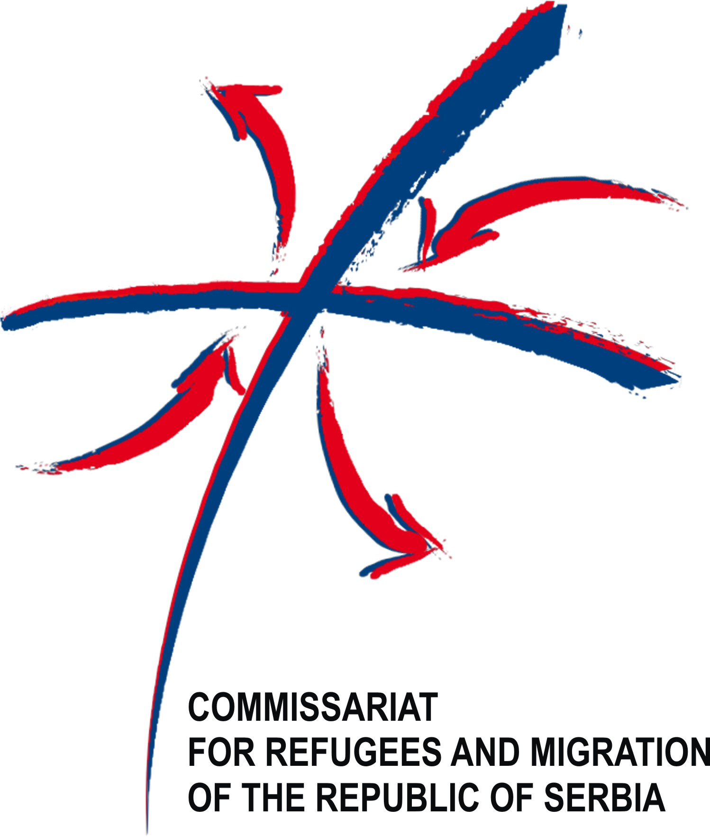

European Union

ON THE WORLD REFUGEE DAY: TWENTY NEW APARTMENTS FOR VULNERABLE IDP FAMILIES IN BUJANOVAC

Bujanovac, 20 June 2014 – Today, when we are marking the World Refugee Day, fifteen internally displaced families from collective centres on the territory of the municipality of Bujanovac and five domicile, socially vulnerable families received the keys to their new apartments in the city of Bujanovac. Thus, these 20 families have obtained a sustainable housing solution thanks to the European Union project “Support to the Implementation of the Strategy for IDPs, Refugees and Returnees in Serbia”. The significance of this project for the municipality of Bujanovac is enormous, as it allowed for closure of the collective centre “Salvatore” the living conditions in which were below human dignity.

This project was funded by the European Union; co-funded and implemented by UNHCR. The total value of the building and household equipment is EUR 358,800. The Commissariat for Refugees and Migration of the Republic of Serbia as a competent institution for solving housing needs of refugees and IDPs has directed the attention of the EU as a donor to the most effective means of resolving the housing issue of this population. The City of Bujanovac donated the land and infrastructure. The project was carried out in cooperation with the NGO Vizija, and the Commissariat for Refugees and Migration of the Republic of Serbia.

The concept of Social Housing in Supportive Environment is included in the Strategy for Development and Social Protection of the Republic of Serbia, and has been assessed as the best and most suitable solution for the remaining residents of collective centres. It provides housing for the most vulnerable groups in need of additional support from the local centres for social welfare. To date, the Social Housing in Supportive Environment concept has been implemented in 42 municipalities throughout Serbia where 976 units were built of which 556 with the European Union funds.

The beneficiaries of apartments in the no. 25, Jašima Đošića Street in Bujanovac will hold the right to use the flats as long as they are in a situation of social need. According to the concept of the project, each building will have a host family to act as a link between the residents and the Centre for Social Welfare in Bujanovac providing them with necessary additional support.

The project “Support to the Implementation of the Strategy for IDPs, Refugees and Returnees in Serbia” funded through the EU pre-accession funds in the total value of EUR 1,400.000 includes four components: construction of prefabricated houses, construction of apartments within the concept of “Social Housing in Supportive Environment”, distribution of construction materials and distribution of dependency reduction grants throughout Serbia. The project provided housing solutions for 167 families and helped close four collective centres in Serbia.

The Commissariat for Refugees and Migrations, together with the donors and implementing partners, has been investing efforts to provide the most adequate durable solutions for refugees and IDPs still residing in the collective centres in the Republic of Serbia.

According to the UNHCR report Global Trends for 2013 published today, the number of refugees, asylum seekers and internally displaced persons reached an alarming 51.2 million, the highest ever since the World War II.

Ovaj projekat finansira Evropska Unija

Za dodatne informacije, obratite se:
Predstavništvo UNHCR za Srbiju: Krunska 58, Beograd
Tel: + 381 11 30 82 103
E-mail: ivanovim@unhcr.org

Delegacija EU u Republici Srbiji
Avenija 19a, Vladimira Popovića 40/V, 11070 Novi Beograd,
Tel no: +381 (0)11 30 83 264
Email: nadezda.dramicanin@eeas.europa.eu

