European Commission

MEMO
Brussels/Frankfurt, 8 October 2014
Embargo: 8 October - 10:15 CET
2014 European Union Prize for Literature
Authors' biographies and synopsis of the winning books

1. Albania- Ben Blushi
Otello, Arapi i Vlorës (Othello, Arap of Vlora). Mapo Editions, 2011
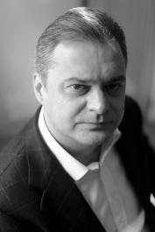
Ben Blushi, born in 1969, graduated in Albanian Language and Literature from the University of Tirana. He was editor-in-chief of the newspaper Koha Jonë and in 1999 embarked upon a political career in the cabinet of the Prime Minister of Albania. For several months he served as Deputy Minister of Foreign Affairs; in 2000 he became the Prefect of Korça, and, the following year, he was appointed Minister of Education. Blushi is currently a Member of Parliament, representing the Socialist Party.
The book is set in the years 1300-1400, in Venice and Vlora. It adapts the characters from one of Shakespeare's most famous tragedies (Othello, the Moor of Venice) but is set more than 100 years before Shakespeare's birth. Above all, Otello, Arapi i Vlorës is a novel about love: the way it can determine fate and change the course of events, often for entire societies and eras.

2. Bulgaria - Milen Ruskov
Възвишение (Summit), Janet 45, 2011
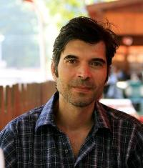
Milen Ruskov (b.1966) is a Bulgarian writer and translator living in Sofia. He graduated in Bulgarian philology from Sofia University in 1995. He has written three novels: Summit (2011) received the Golden Century Award from the Bulgarian Ministry of Culture, the Hristo G. Danov National Award for fiction, and the Elias Canetti Award for fiction. Thrown into Nature (2008) was awarded the Bulgarian Novel of the Year Prize. And Little Encyclopaedia of Mysteries (2004) was awarded the Bulgarian Prize for Debut Fiction.
Summit is set in Turkish-ruled Bulgaria in 1872, the feverish period known as the Bulgarian Revival. The pretentious pomp of revolutionary ideals is filtered through the consciousness of the practical Bacho Gicho and his credulous companion Asen, in a rich, crude Renaissance language which demands to be read out loud. Ruskov’s daring blows away all the patriotic clichés, without underestimating the desperate heroism of the times.
3. Czech Republic - Jan Němec
Dějiny světla (A History of Light). Host, 2013
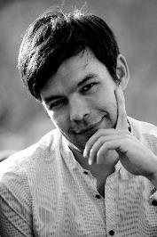
Jan Němec, born 1981, received his MA degree in Religious and Social Studies from Masaryk University in Brno, and in Theatre Dramaturgy from the Janáček Academy of Music and Performing Arts in Brno. Němec works as an editor for the monthly literary magazine Host, and as a playwright for the ČT Art TV channel.
A History of Light is a biographical novel about renowned photographer František Drtikol.
So who was František Drtikol? A dandy from a small mining town, a world-famous photographer whose business went bankrupt, a master of the nude image who never had much luck with women, a mystic and a Buddhist who believed in communism, a man of many contradictions.

4. Greece - Makis Tsitas
Μάρτυς μου ο Θεός (God is my witness). Kichli, 2013
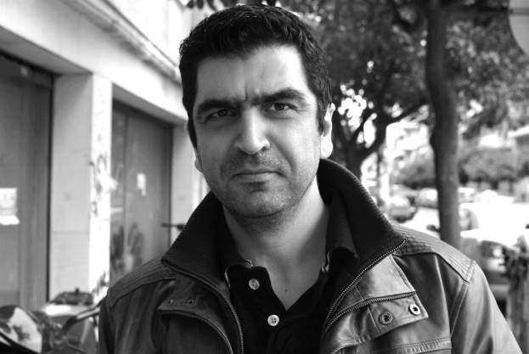
Makis Tsitas was born in 1971 in Giannitsa, Greece. He studied journalism in Thessaloniki, where he worked in radio. Since 1994 he has lived in Athens and works in publishing. He is the director of diastixo.gr, a literary and cultural internet journal.
In this humorous, moving and perceptive novel, an anti-hero of our time, who wants nothing more than to live with dignity – having reached his fifties with no job and uncertain health – narrates the trials and betrayals he has suffered from employers, from the women he meets, and from his own family. Through his torrential monologue, replete with everyday occurrences and ebullient fantasies, we follow a simple man's struggle to remain upstanding.
5. Iceland -Oddný Eir
Jarðnæði (Land of Love, Plan of Ruins). Bjartur, 2011
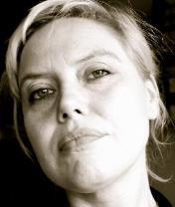
Oddný Eir, born in 1972, completed a doctoral degree at Sorbonne University and carried out research in Icelandic museum field studies. She has written three autobiographical novels, translated and edited literary works, organised visual arts events and ran a visual arts space in New York and Reykjavík (Dandruff Space) in collaboration with her brother, archaeologist Uggi Ævarsson. Together they run the publishing company Apaflasa (Monkey Dandruff).
Land of Love, Plan of Ruins is written in the form of a diary, describing a period in the narrator's life where she is preoccupied by the search for a place to belong and an urge to settle down. Paradoxically enough, this drives her to embark on all kinds of journeys, physically and mentally, through time and space, in order to find answers to questions that not only concern her personally but also the whole of mankind.

6. Latvia - Janis Jonevs
Jelgava '94. Mansards, 2013
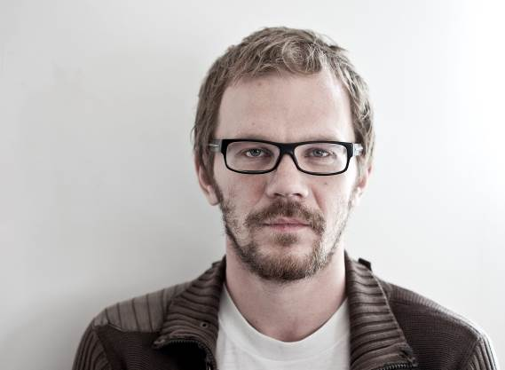
Born in 1980 in Jelgava (Latvia) Janis Jonevs was educated at the Jelgava State Gymnasium and graduated with a Master’s degree from the Latvian Academy of Culture. Jonevs works as a copywriter and, since 2002, also as a reviewer and translator from French.
The story is set in the 1990s in the Latvian city of Jelgava and looks at the craze during this period for the alternative culture of heavy metal music. Jonevs takes the reader deep inside the world described in the novel: combining the intimate diary of a youngster trying to find himself by joining a subculture, as well as a skilful, detailed and almost documentary-like depiction of the beginnings of the second independence of Latvia.

7. Liechtenstein - Armin Öhri

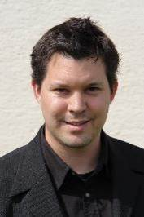
Die dunkle Muse: Historischer Kriminalroman (The Dark Muse). Gmeiner, 2012

Armin Öhri (b. 1978) studied history, philosophy and German linguistics and literature. His works tend to be set against a historical backdrop and are based primarily on literary examples of the 19th century, such as entertaining 'feuilleton' novels in the crime genre. Öhri works at a business school in Switzerland.
The Dark Muse – the first part of a chronological series of novels – is a complex historical crime story that turns the established formula of a whodunnit upside-down: on the very first pages the reader already gets to know the murderer, a gentle professor of philosophy. Through the eyes of the protagonist, a semi-professional detective, the reader follows the ambitious story through the streets and infamous sites of late 19th century Berlin.

8. Malta - Pierre J. Mejlak
Dak li l-Lejl Iħallik Tgħid (What the Night Lets You Say). Merlin Publishers, 2011
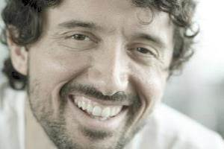
Born in Malta in 1982, Pierre J. Mejlak has been writing since he was young. He has written books for children, adaptations, a novel for adolescents and two collections of short stories, winning numerous awards. Two-time winner of the Malta Journalism Award, Mejlak worked as a journalist from 1999 to 2005. He was a BBC correspondent, a regular columnist for Malta's daily In-Nazzjon and produced radio shows for various national radio stations.
The 10 stories in this collection, just like any self-respecting collection of medieval tales, are framed by a prologue and an epilogue. The tension in many of the stories arises from the coming together of the past (or, at least, a previous way of life) and the present. Many of the narrators are travellers, moving from one point of their existence to another, trying to understand a life that they have lived but never fully comprehended, or trying to undo a part of the past that did not go according to plan.
9. Montenegro - Ognjen Spahić
Puna glava radosti (Head full of joy). Nova knjiga, 2014
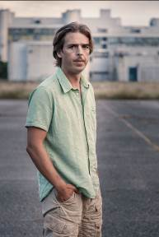
Ognjen Spahić was born in 1977 in Podgorica, Montenegro. He has published two collections of short stories: Sve to (All That) and Zimska potraga (Winter Search). His novel Hansenova djeca (Hansen’s Children) won the 2005 Meša Selimović Prize, awarded to the best new novel from Croatia, Serbia, Montenegro, and Bosnia-Herzegovina. He was a resident writer in 2007 at the University of Iowa's International Writing Program. In 2011 he was the recipient of Romania's Ovid Festival Prize, awarded to a young talent.
Puna glava radosti presents 16 unusual tales featuring episodes from the life of each story's hero. Each story is told by an omniscient narrator or the hero himself, and they paint a picture showing the collision of the outer and inner world of modern man, providing a distinct interpretation of the universal values of life.

10. The Netherlands - Marente de Moor
De Nederlandse maagd (The Dutch Maiden). Querido, 2010
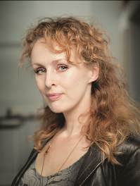
Marente de Moor (b. 1972) worked as a correspondent in Saint Petersburg and wrote a book on her experiences, Peterburgse vertellingen (Petersburg Stories), published in 1999. She made a successful debut as a novelist in 2007 with De overtreder (The Transgressor). For her second novel, De Nederlandse maagd, de Moor was awarded the AKO Literature Prize 2011.
In the summer of 1936, Dutch doctor Jacq sends his 18-year-old daughter Janna to stay with Egon von Bötticher, a German he befriended as a young man. Egon is an enigmatic figure, as attractive and irresistible as Heathcliff, and Janna inevitably falls for him. However, De Nederlandse maagd is much more than just a story about love and the loss of innocence. Through Janna’s experiences, de Moor evokes the unsettled atmosphere of an era as a major historical shift occurs, vividly portraying the uncertainty and tensions that preceded the Second World War.
11. Serbia - Uglješa Šajtinac

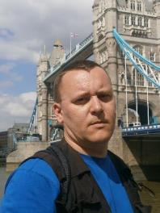
Sasvim skromni darovi (Quite Modest Gifts). Arhipelag, 2011
Uglješa Šajtinac (b. 1971) graduated in 1999 from the Faculty of Dramatic Arts in Belgrade. Between 2003 and 2005, he was a playwright at the Serbian National Theatre in Novi Sad. He edited a collection of new plays by young authors, PROJEKAT 3, which were staged in May 2005 at the Serbian National Theatre. Since 2005, he has been teaching drama at the Academy of Arts in Novi Sad. He has been a member of the Serbian Literary Association since 2007.
Sasvim skromni darovi is an epistolary novel in which two brothers exchange emails about their seemingly ordinary, but essentially unusual and exciting existence in Serbia and the United States. Through a form of family chronicle, the novel intertwines numerous narratives about the experiences of individual characters, while raising a number of challenging questions about the world we live in.

12. Turkey - Birgül Oğuz
Hah (Aha), short stories. Metis, 2012
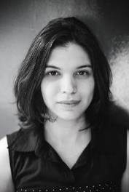
Birgül Oğuz (b. 1981) received her BA in Comparative Literature and MA in Cultural Studies from İstanbul Bilgi University. Her short stories, essays, articles and translations have been published in various Turkish literary magazines and newspapers. Last winter she was a writer-in-residence at quartier21 in Vienna. She is currently studying a PhD at Boğaziçi University and lecturing on text analysis and the European novel at Moda Sahnesi and Nazım Hikmet Academy in Istanbul.
The eight and a half stories in Hah contemplate the psychology of mourning and melancholia, and the politics of mourning in particular. Hah, in search of a new literary agency to transform traumatic loss into meaningful narrative, seeks to answer these questions: how can one mourn when mourning is impossible? How can one write about mourning when it is impossible to find the means to narrate it? And how can one not write when writing is the only way to mourn?
13. United Kingdom - Evie Wyld
All the Birds, Singing. Vintage, 2013
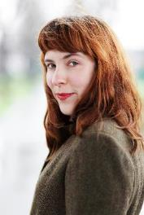
Evie Wyld lives in Peckham, London, where she runs the Review Bookshop. Her first novel, After the Fire, A Still Small Voice, won the John Llewellyn Rhys Prize and a Betty Trask Award. It was shortlisted for the Orange Prize for New Writers, the Commonwealth Prize and the IMPAC award. In 2013, Evie was named as one of Granta's Best of Young British Novelists, having previously been named by the BBC as one of the 12 best new British writers.
Jake Whyte is the sole resident of an old farmhouse on an unnamed British island, a place of ceaseless rains and battering winds. It’s just her, her untamed companion, Dog, and a flock of sheep. Which is how she wanted it to be. But something is coming for the sheep – every few nights it picks one off, leaving it in rags.

